ST BENEDICT’S COLLEGE



|  |  |  |  |
| --- | --- | --- | --- |
| **SUBJECT** | Information Technology | **DATE** | Nov 2016 |
| **GRADE** | 11 | **MARKS** | 150 |
| **EXAMINER** | J. Nocton-Smith | **MODERATOR** | L. Bothma, K. Aitken, D. Kench |
| **NAME** |  | **DURATION** | 2½ hours |
| **CLASS** |  |  |  |
|  |  |  |  |

|  |  |  |  |  |  |
| --- | --- | --- | --- | --- | --- |
| **COGNITIVE LEVELS** | | | | | |
| LOW ORDER | 35 % | **MIDDLE ORDER** | 33 % | HIGH ORDER | 31 % |

|  |  |
| --- | --- |
| INSTRUCTIONS |  |
| COMMENT |  |
|  |  |
|  |  |
| TEACHER’S SIGNATURE |  |
| PARENT’S SIGNATURE |  |

question 1 TERMINOLOGY 7 marks

Various options are provided as possible answers to the following questions. Choose the correct answer and write only the letter (A-D) next to the question number, for example 1.2 D

1.1 The CPU chipset is made up of the Northbridge and the Southbridge. Which of the following components connects to the Northbridge? (1)

A PCI

B AGP

C ISA

D IDE

1.2 The type of file compression that eliminates "unnecessary" bits of information, tailoring the file so that it is smaller. (1)

A Lossless

B Lossy

C ZIP

D Defragmentation

1.3 Which of the following is NOT a cellular technology? (1)

A WiFi

B LTE

C HSPA

D 3G

1.4. Which data validation technique inserts an 8th bit every 7 bits to ensure the number of 1s are even or odd? (1)

A checksum

B parity

C check digit

D binary digit

1.5 A digit added to a string of numbers for error detection purposes, computed from the other digits in the string. (1)

A checksum

B parity

C check digit

D binary digit

1.6 Which of the following memory types are volatile? (1)

A DRAM

B Flash

C PROM

D EEPROM

1.7 The fraudulent practice of sending emails purporting to be from reputable companies in order to induce individuals to reveal personal information, such as passwords and credit card numbers, online. (1)

A. pharming

B. ransomware

C. phishing

D. identity theft

question 2 TERMINOLOGY 8 marks

Provide definitions for the following terms – do not just break out the Acronyms

2.1 AUP (2)

2.2 DNS (2)

2.3 Machine Cycle (2)

2.4 Firewall (2)

Scenario

UBER

Uber is a San Francisco-based company, founded in 2009. It describes itself as a "pick-up" service that connects passengers with vetted private drivers (although how 'vetted' the drivers are is a cause of some consternation). Uber's App is backed by Google, integrated into Google Maps, and available on the major smartphone platforms. It allows customers to order taxis through their smartphone based on their location. They can see who their driver will be, and then track the arrival of their car.

Users are able to check the price before they accept a ride. Enter a destination to get an estimate for the cost of your ride. The fare estimate is based on the distance of the trip, calculate by finding GPS coordinates, and the estimated duration of the trip. By linking to Google maps they are able to estimate delays on the route.

Uber have a small office in Johannesburg. You will be spending some time in their offices for your work experience.

Question 3 Hardware and Software 26 marks

Uber are hiring a new marketing manager to grow the Johannesburg office and you have been asked to review the specs of two laptops they are considering purchasing for her. She will need to spend a lot of time out of the office visiting clients.

Examine the specs in the table below.

|  |  |  |
| --- | --- | --- |
| **Laptop Image** | MB PRO.jpg | HP Envy.jpg |
| **Name** | MacBook Pro | HP Envy |
| **Price** | R14 999.00 | R15 750.00 |
| **Processor** | | |
| **Frequency** | 2.7 GHz | 2.5 GHz |
| **Family** | Intel Core I5 | Intel Core I7 |
| **Cache** | 3 MB | 4 MB |
| **Cores** | 2 | 2 |
| **Memory** | | |
| **Internal memory** | 8 GB | 8 GB |
| **Memory Type** | DDR3 SDRAM | DDR3 SDRAM |
| **Networking** | | |
| **Bluetooth** | Yes | Yes |
| **3G and 4G** | No | No |
| **Ehternet LAN** | No | 10/100/1000 Ethernet LAN |
| **Wifi** | 802.11ac | 802.11b/g/n |
| **Storage** | | |
|  | 256GB Flash | 1 TB 5400 rpm SATA SSHD |
| **Graphics** | | |
|  | Intel Iris Graphics 6100 | NVIDIA GeForce GTX 950M (4 GB DDR3L dedicated) |

3.1 Which device has the better processor? Give ONE reason for your choice (2)

3.2 Both of the devices have cache:

3.2.1 What is the purpose of cache? (2)

3.3 All computer systems contain RAM and ROM.

3.3.1 State TWO major differences between RAM and ROM. (2)

3.3.2 Explain the purpose of ROM. (1)

3.3.3 Why are the ROM specifications never listed in the technical specifications of devices? (1)

3.4 The HP laptop has a graphics card with 4GB of dedicated RAM. What are the advantages of the additional RAM in the graphics card? Give TWO reasons for your answer. (2)

3.5 The Ethernet specifications for the HP are given as Integrated 10/100/1000 Gigabit Ethernet LAN

3.5.1 What does “integrated”’ imply? (1)

3.5.2 What do the numbers 10/100/1000 tell us? (1)

3.5.3 The MacBook Pro does not provide Ethernet connectivity. Do you see this as a limitation? Give TWO reasons for your answer. (2)

3.6 Explain why none of these devices are 3G or 4G compatible. (2)

3.7 The processors of both devices are multi core. Define each of the FOUR terms.

3.7.1 Multi –processing

3.7.2 Multi-tasking

3.7.3 Multi-threading

3.7.4 Hyper-threading (4)

3.8 Virtual memory does not appear as a specification. Explain what virtual memory is and how it is used. (3)

3.9 Which device would you recommend for the marketing manager? Give TWO reasons for your choice. Justify your answer. (3)

Question 4 Software 7 marks

The Uber technology platform drives the success of Uber.

4.1 All Uber drivers need to have a smartphone to have access to the Uber technology platform.

4.1.1 Name one operating system developed exclusively for use of a smart phone. (1)

4.1.2 List TWO features of a mobile operating system that differ from the operating system of a laptop or a desktop. (2)

4.2 Uber are encouraging businesses to integrate their Apps with Uber, for example AMAZON can use Uber to make their deliveries. To achieve this, Uber have made available their APIs which helps your App make HTTP requests to the Uber Rides API.

Would this be an example of high level or a low language? Give ONE reason for your answer. (2)

4.3 Describe an interrupt and provide an example. (2)

Question 5 Networks 26 marks

There are 10 full time employees at the Johannesburg office. Due to the nature of their business, network access and communication are critical.

5.1 There is a small LAN in the office using a star topology. Name two network devices needed for a computer to be connected in a star topology. (2)

5.2 Name TWO types of cables that can be used in LAN networks. (2)

5.3 Given that this is a small network, which type of cable would you recommend if all the wired nodes are within a 60 metres radius? Why would you choose this type of cable? Give ONE reason for your answer. (2)

5.4 What technology and device would you choose to connect this LAN to the internet? Justify your choice for both the device and the technology. (4)

5.5 The LAN will be making use of Ethernet.

5.5.1 Name two features of Ethernet other than CSMA/CD. (2)

5.5.2 Explain how CSMA/CD works. (2)

5.5.3 Why is CSMA/CD no longer necessary with modern network technology? (1)

5.6 The office receives visits from a number of drivers needing to register with Uber. All registrations need to be completed online. The manager has asked you to investigate setting up a hotspot.

5.6.1 What is the purpose of a hotspot? (2)

5.6.2. Name TWO devices required to setup a hotspot? (2)

5.6.3 Hotspots are open to eavesdropping. What security measures can the Uber office implement for the hotspot? (2)

5.7 Navigation: other than having a properly working vehicle, it is the most important aspect of Uber’s business. The Uber App functions with navigation Apps such as Google Maps.

Name and explain the technology being used to assist in navigation. (3)

5.8 When the drivers of the vehicles are connected to the Uber system they are part of a WAN or a MAN. Explain what this means. (2)

Question 6 e-Communication and security 24 marks

6.1 Java Apps will make HTTP protocol requests to the Uber Rides API.

6.1.1. Define the term protocol. (2)

6.1.2 Explain the difference between HTTP and HTTPS by first providing a definition for each. (3)

6.1.3 Give three reasons for using Apps to access web based data rather than a mobile browser. (3)

6.2 You have been asked to prepare training information for the drivers to educate them on the risks of social engineering.

Name and describe TWO forms of social engineering that are most applicable in this scenario and describe how the drivers can best protect themselves. (6)

6.3 Uber has employed a large team of security experts to safeguard the data of its drivers and users.

Name and describe 2 risks to their data and how to best protect against any data loss. (6)

6.4 Uber have a warning to users on their privacy statement that they make use of cookies.

6.4.1 What is a cookie? (2)

6.4.2 Describe how Uber could make use of cookies. (2)

Question 7 Social 15 marks

7.1 The Uber Advanced Technology Center (ATC) is testing a fleet of driverless cars in Pittsburgh. Now many taxi drivers are fearful of losing their jobs.

Explain what artificial intelligence is and how it is being implemented in driverless cars. Do you think the taxi drivers’ fears are justified? Explain. (5)

7.2 The ATC have openings for the following roles

* Network Manager
* Software developers (programmers)
* Database analysts
* Security analysts

Choose one of the roles and suggest 4 key duties and skills required for this role. (4)

7.3 Explain the term Globalisation. (2)

7.3.1 How has Uber benefited from globalization? (2)

7.4 Johannesburg is ranked as the 7th in the TOP 10 Uber Cities ahead of London and Miami. Discuss why you think Johannesburg is so highly ranked. (2)

Question 8 Software development 37 marks

8.1 Java is being used by many App developers as it enforces an object-oriented programming model (OOP). Describe the following OOP terms:

8.1.2 Encapsulation (2)

8.1.3 Information hiding (2)

8.2 Developers are able to link their Apps to Uber by embedding an Uber Ride Request Button into the App. To implement a RideRequest button you have to import the RideRequestButton with the following Java code:

import com.uber.sdk.android.rides.RideRequestButton;

8.2.1 What is the purpose of the import statement? (1)

8.2.2 You can add the button to your program with the Java code:

RideRequestButton requestButton = new RideRequestButton(context);

What is the purpose of this statement? (1)

8.2.3 What is the name of the Class? (1)

8.2.4 What is the name of the object getting created? (1)

8.2.5 What is the general name of the method being called? (1)

8.2.6 This type of method is often overloaded. Explain what this means. (2)

8.2.7 What is the difference between a typed and a void method? (2)

8.3 The App will be viewed on many different types of devices including mobile devices.

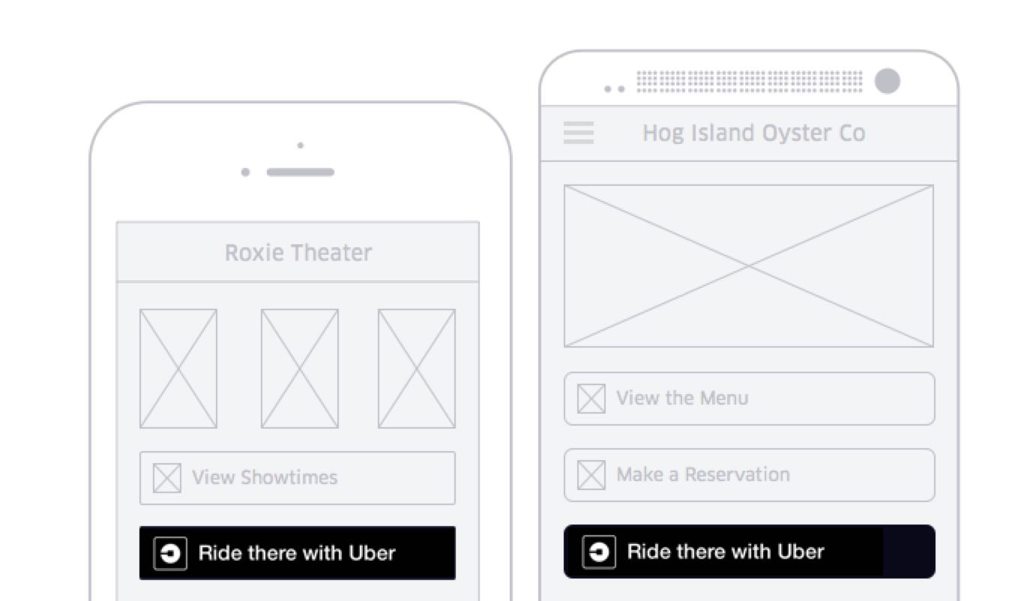

8.3.1 When designing screens you need to implement as many features as possible to limit the chance of users entering incorrect data. Describe two GUI features that can be used. (4)

8.4 The graphic below details the base fares charged by Uber. They also use surge pricing for peak times e.g. 4pm - 8pm in the evenings. A surge multiplier would be applied to the base fare. Users will always be warned ahead of their trip if surge pricing is in effect and what the surge pricing will be.

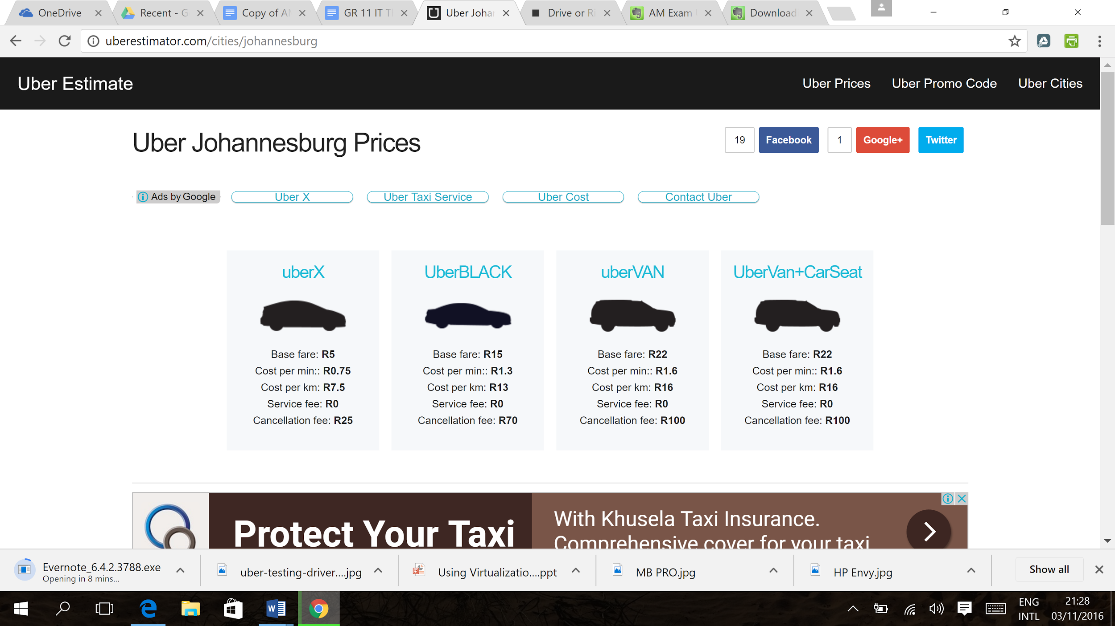

You need to build a fare estimator App.

8.4.1 What inputs will you require? (4)

8.4.2 Write down an **algorithm** to estimate the fare. (10)

8.5 The company has a large server based DBMS.

8.5.1 Name an example of a server based DBMS. (1)

8.6 One of the tables in the database stores information about the drivers. It has the following **sample** layout.

|  |  |  |  |  |  |
| --- | --- | --- | --- | --- | --- |
| **driverID** | **driverSurname** | **driverFirstname** | **licenseCode** | **licenseExpiry** | **fkCarRegistration** |
| 9402115093089 | Botha | Jason | 08 | 01/06/2017 | CS 41 DR GP |
| 7289005609080 | Booi | Flora | 08 | 05/09/2020 | HR 67 FG GP |
| 7902120086089 | Brown | Thabang | 10 | 10/02/2020 | AB 12 CD GP |

8.6.1 Which field would you use as the primary key? (1)

8.6.2 What is the purpose of the primary key? (1)

8.7 A SQL programmer wants to count the number of drivers in each licence code. He only wants to list the licence codes that have more than 10 drivers. Would this SQL statements require a HAVING or a WHERE? Explain your answer. (3)